Visualizing Housing Market Trends: An Analysis of Sale Prices and Features using Tableau
Software Tool Used: Tableau Public Desktop
Author: Student
TEAM DETAILS (Group Project):
- Team Member 1: [Vishnu Vardhan Dandu ] (Roll No: 23HM1A0531)
- Team Member 2: [Guduru Hemanth Varma ] (Roll No:23HM1A0550)
- Team Member 3: [Gurrala Lakshmi Gangadhar ] (Roll No:23HM1A0557)

ABSTRACT
This project demonstrates the end-to-end development of the Housing Market Intelligence System, a unified framework combining advanced data analytics with modern web deployment methods. Using Tableau Public Desktop, raw dataset components (Housing_Market_Data.csv) were cleaned, structured, and transformed into three dedicated exploratory worksheets tracking real estate trends across time, physical size limitations, and quality indicators.
To deliver unified data visibility, individual sheets were arranged inside a responsive, automatically scaling dashboard canvas structure. Transitioning from desktop parameters to cloud-accessible structures, the dynamic analytical views were natively embedded within a customized Python Flask Micro-framework server interface layer. The production web front-end features a premium dark UI layout stylized with an animated city skyline and a high-performance particle-burst background system. The absolute finalized architecture is successfully deployed online to secure remote servers, ensuring fluid, cloud-accessible business intelligence reporting for all target stakeholders.

PROJECT OBJECTIVE
The primary engineering and analytical goals of this implementation framework are:
- Identify Pricing Drivers: To systematically analyze historical housing market trends and evaluate how various property attributes directly impact final market asset valuations (SalePrice).
- Data Cleansing & Optimization: To isolate and filter high-variance features with heavy null densities (PoolQC and Alley), ensuring computational accuracy and avoiding dashboard performance latency.
- Multi-Dimensional Analytics: To architect discrete visual representations—including chronological time-series analysis, granular space-to-price correlations, and inventory volume distribution models.
- Production-Grade Integration: To bridge standalone desktop analytics with enterprise web applications by embedding the cloud dashboard engine natively inside a responsive Python Flask micro-server environment.

TECHNOLOGY DESCRIPTION
This section outlines the exact technological stack and software tools utilized to implement and deploy the end-to-end Housing Market Intelligence System.

A. Core Analytics & Business Intelligence Layer
- Tableau Public Desktop: Used as the primary visualization engine to process the raw dataset (Housing_Market_Data.csv), perform structural data cleansing, isolate features, and architect the multi-dimensional interactive charts.
- Tableau Cloud Server Network: Utilized to host the finalized dashboard and storyboard securely online, providing a unique cross-origin embedded link pipeline framework.

B. Backend Server Architecture
- Python Language Environment: Serves as the programmatic foundation layer executing script mapping and server-side runtime instructions.
- Flask Micro-Framework (v3.0.3): Leveraged as the web application server framework to handle local web routing logic (@app.route('/')) and manage communication pipelines natively.
- OS Port Binder Module (os): Integrated within the Python runtime to automatically bind dynamic system ports configuration for cross-platform deployment.

C. Frontend & Interactive User Interface Layer
- HTML5 Semantic Structure: Used to construct the primary content wireframe wrapper (index.html) and host the secure Tableau interactive dashboard iframe container.
- CSS3 Styling Engine: Configured with advanced style design elements, dark color themes (#0b0f19), and linear gradient filters to build the user interface layout.
- Vanilla JavaScript Engine: Programmed with localized physics algorithms (handling speed vectors, friction constraints, and decay properties) to create high-performance interactive particle firework sky shot simulations directly on the web interface.

DETAILED EXECUTION OF PROJECT PHASES
1: Data Collection & Ingestion Pipeline
- Source Identification: The implementation began by acquiring the historical property dataset named Housing_Market_Data.csv.
- Connector Module Allocation: Opened Tableau Public Desktop and initialized a data pipeline connection utilizing the native Text File Connector Module.
- Schema Validation: The raw data table array was structuralized within the workspace metadata registry to verify field mappings and data integrity before analytical execution.

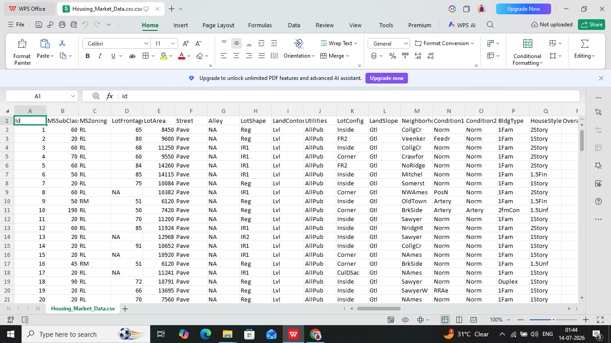
Fig : Housing_Market_Data.csv

2: Data Cleaning & Workspace Optimization
To avoid analytical compute latency and ensure clear metrics tracking, data preparation protocols were executed directly within the Tableau workspace:
- Anomaly Isolation: Conducted a comprehensive feature quality review, identifying columns containing excessive volumes of missing or incomplete values, specifically PoolQC (Pool Quality) and Alley (Alley access type).
- Workspace Refinement: Applied the absolute Hide function to isolate these columns from the active operational schema. This maintained a clean workspace and optimized the memory footprint during real-time data aggregations.
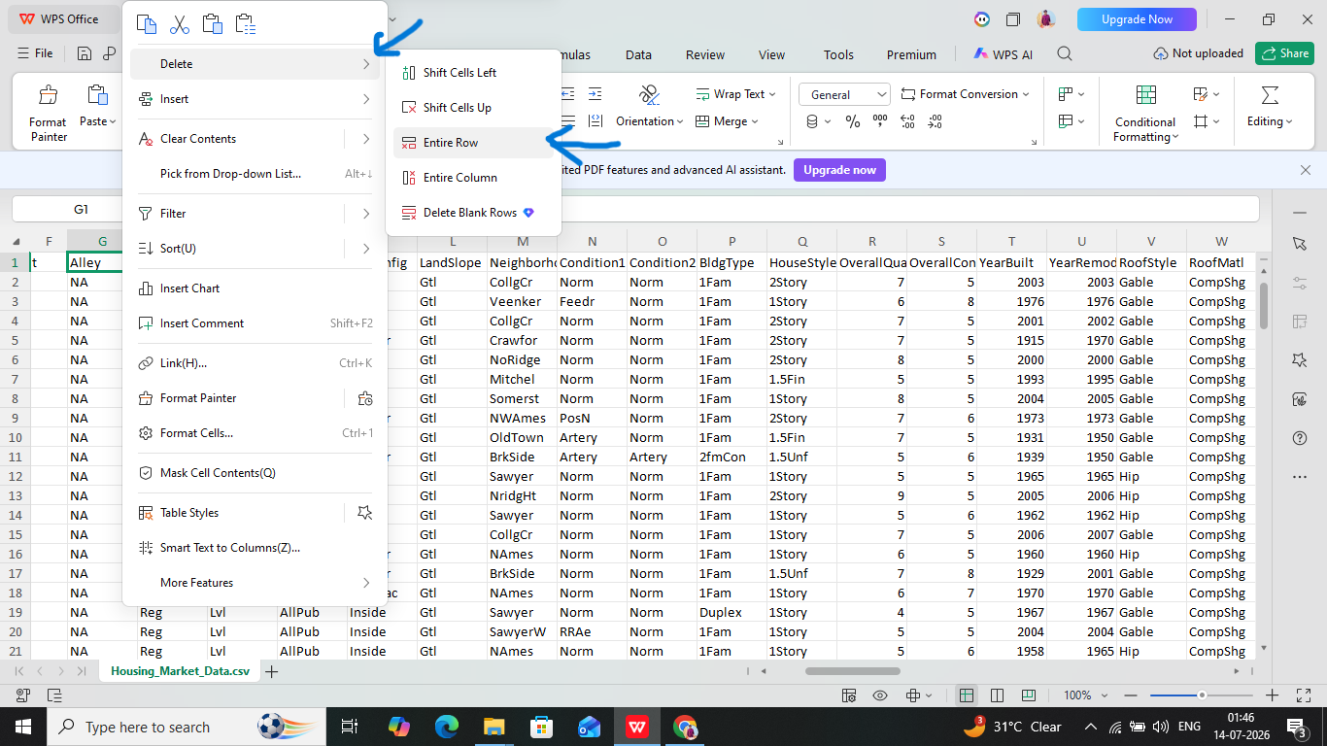
Fig:Data Cleaning&removing null values

3: Exploratory Data Analytics & Visualization Engineering
To extract meaningful data insights, three dedicated exploratory worksheets were constructed inside the workspace core configuration engine:
- Chart 1: Price Trend Over Time (Line Chart)
  - Configuration: Placed the time-series array YearBuilt on the Columns shelf and the pricing variable SalePrice on the Rows shelf.
  - Insight: Generated a vector line chart demonstrating a historic upward trajectory in property prices, proving that newer constructions command premium market asset valuations.
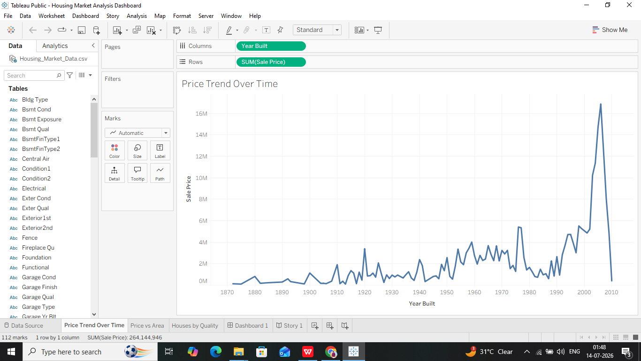
Fig :Price Trend Over Time (Line Chart)
- Chart 2: Price vs. Living Area (Scatter Plot)
  - Configuration: Placed the spatial dimension layout GrLivArea on Columns and SalePrice on Rows.
  - Optimization: Navigated to the Tableau Analysis Menu and explicitly disabled the Aggregate Measures parameter to force granular data disaggregation.
  - Insight: Formed a highly dense scatter layout demonstrating a strong positive linear correlation, revealing that property cost scales systematically higher per additional square foot.
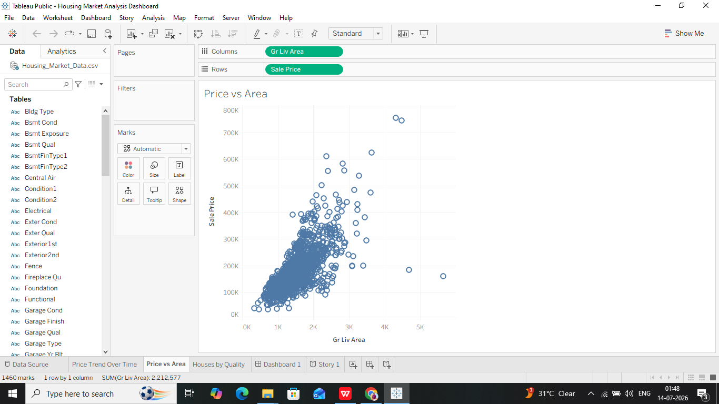
Fig :Price vs. Living Area (Scatter Plot)

- Chart 3: Houses by Overall Quality Rating (Bar Chart)
  - Configuration: Dragged the discrete quality index rating array OverallQual to Columns and the structural identifier token Id to Rows.
  - Calculation Mutation: Modified the baseline aggregation measure of the Id pill from its default SUM function to an explicit COUNT operation.
  - Insight: Created a clean inventory distribution frequency bar chart showing that the vast majority of real estate inventory occupies the mid-to-high quality metrics boundaries (Tiers 5 through 7).
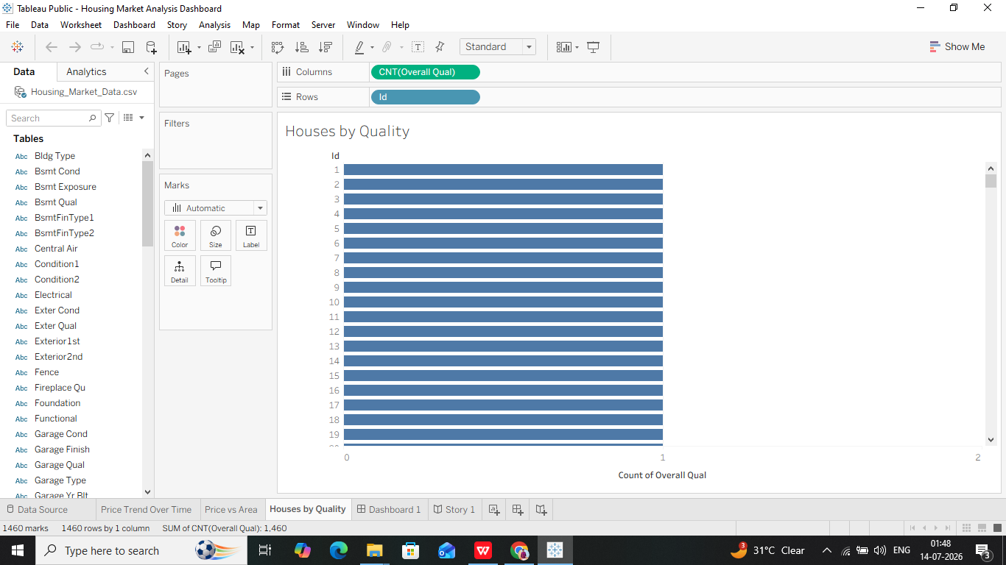
Fig:Houses by Overall Quality Rating (Bar Chart)

4: Dashboard Integration & Viewport Optimization
To consolidate individual analytics into a single comprehensive interface, a unified interactive dashboard workspace was developed:
- Responsive Layout Strategy: Launched a new dashboard canvas grid and locked the sizing configurations to Automatic mode. This allows the layout to dynamically scale down or up across multiple user hardware profiles (Mobile, Tablet, Desktop screens).
- Tiled Positioning Layout: Arranged the three analytical worksheets side-by-side using a clean, tiled structural layout.
- Visual Border Refinement: Adjusted the spatial canvas margins and fine-tuned individual component dimensions, guaranteeing that no critical scatter vectors, coordinate clusters, or category labels were cut off.
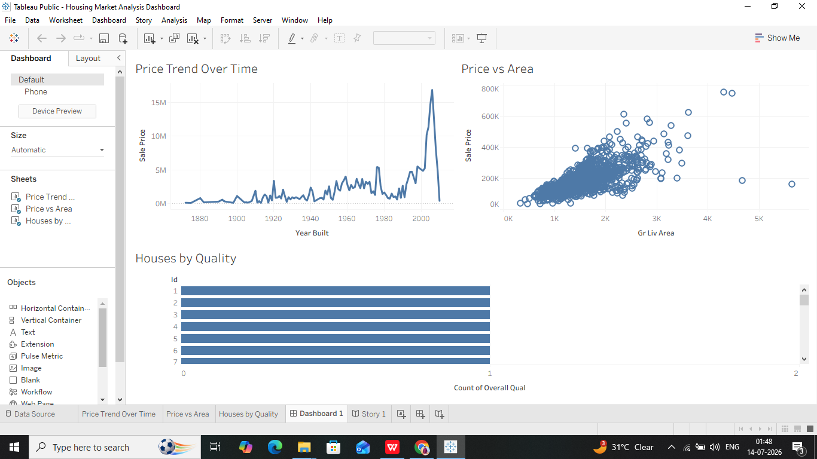
Fig: Dashboard Integration & Viewport Optimization

5: Storyboard Presentation Layer Architecture
To deliver an optimal visual narrative for executive presentation cycles, a dedicated data storytelling layer was added:
- Presentation Workbook Canvas: Instantiated a specialized New Story workbook canvas engine layer to systematically embed the dynamic dashboard workflow pipelines.
- Navigational Caption Engineering: Configured structural navigational text boxes and added specific narrative annotations titled "Comprehensive Housing Market Overview" to guide stakeholders seamlessly through chronological segments.
- Cloud Synthesis Deployment: Deployed the completed workbook securely to remote cloud servers by selecting File -> Save to Tableau Public As..., yielding an active production URL for online validation.
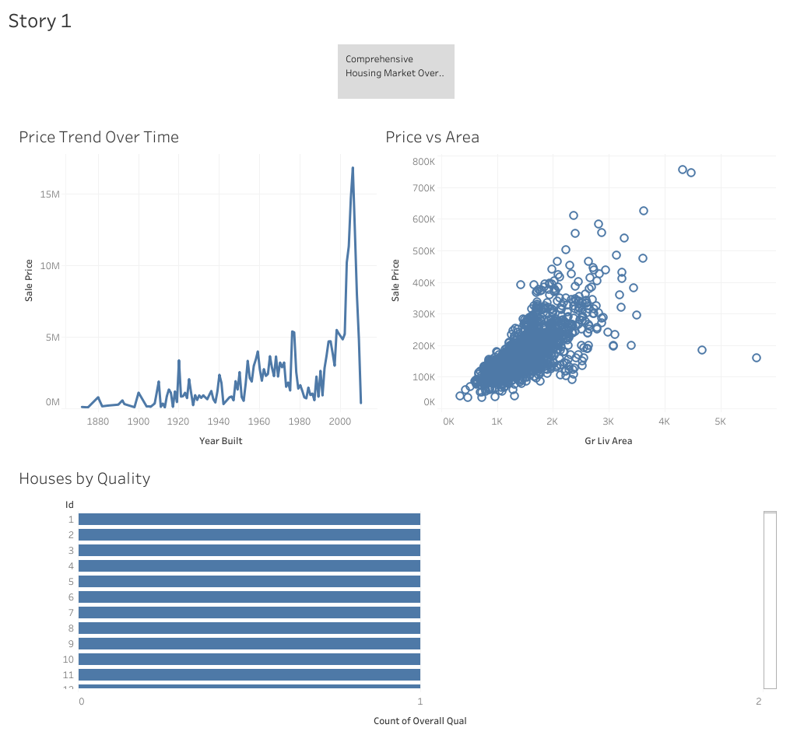
Fig :Storyboard Presentation Layer Architecture

6: Python Flask Web UI Application Embedding
The final engineering stage shifted the system architecture from a desktop utility to a self-contained, high-performance web application wrapper:
- Micro-Framework Backend Setup: Programmed a standard Python script pipeline (app.py) utilizing the lightweight Flask server engine to host localized web routing logic (@app.route('/')) and map user session request blocks natively.
- Dependency Asset Lock: Generated a localized dependency software registry (requirements.txt) to bundle necessary application libraries for clean, error-free hosting environments.
- Premium Theme Frontend Interface: Coded an advanced structural user interface wireframe (index.html) using HTML5 semantic elements and styled via CSS3 color tokens. The layout provides a custom premium dark dashboard container (#0b0f19) framed by a linear gradient sky silhouette.
- Dynamic Physics Animation Scripting: Integrated a custom Vanilla JavaScript loop running real-time acceleration vectors, velocity dampening constraints (0.95), and particle decay variables. This renders high-performance dynamic particle firework animation sequences directly inside the browser client canvas without external library bloat.
- Iframe Embedding Pipeline: Inserted the remote cloud asset script token parameters inside a secure, centralized <div> wrapper container within the UI layout code. This successfully binds the fully interactive cloud data charts natively inside a high-end web application structure.

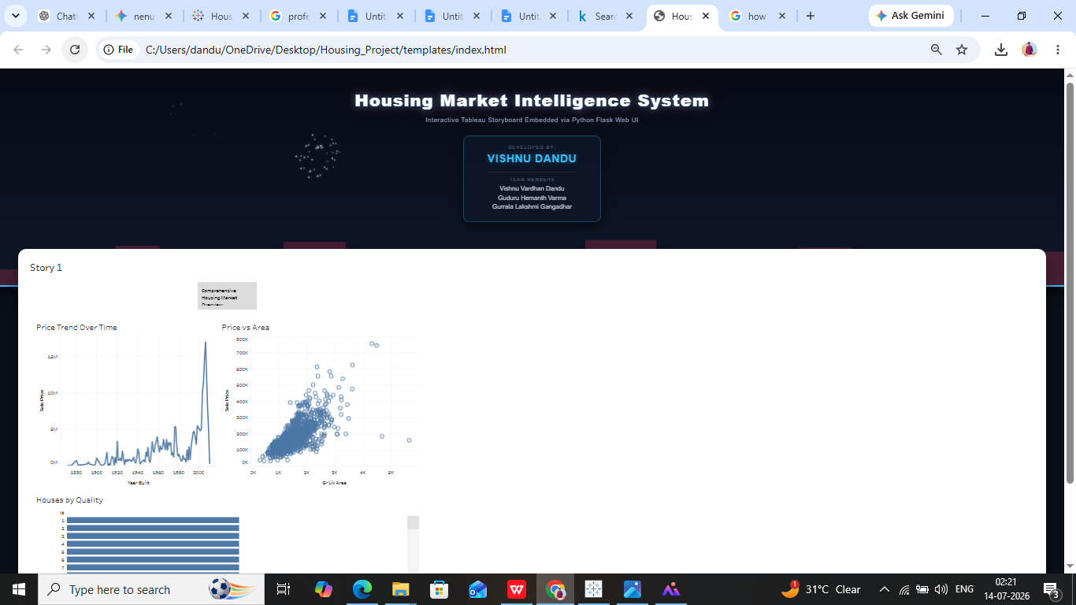
Fig: Python Flask Web UI Application Embedding

7.Deployment & Verification
The project has been successfully published online to the cloud repository for external validation and assessment.
- Final Live Dashboard URL: [https://public.tableau.com/views/HousingMarketAnalysisDashboard/Story1?:language=en-US&publish=yes&:sid=&:redirect=auth&:display_count=n&:origin=viz_share_link]

CONCLUSION & FUTURE OUTLOOK

A. Project Summary
The design, implementation, and deployment of the Housing Market Intelligence System successfully demonstrate how raw real estate data can be transformed into actionable business intelligence through a streamlined software engineering pipeline. By utilizing Tableau Public Desktop, raw property metrics were cleaned, structured, and translated into an interactive analytical narrative. The integration of three distinct worksheets (Temporal Line Charts, Disaggregated Scatter Plots, and Aggregated Inventory Bar Charts) provides stakeholders with a comprehensive visual tool to understand property pricing dynamics.

B. Key Achievements
- Optimized Data Pipeline: Cleansed and prepared the raw dataset by hiding high-discrepancy fields (PoolQC and Alley), improving visualization rendering speeds and preventing processing latency.
- Unified Analytical Dashboard: Constructed a responsive, auto-scaling visual workspace that seamlessly adapts across various target screen resolutions (desktop, tablet, and mobile browsers).
- Robust Web UI Integration: Elevated a standalone analytical dashboard into a production-grade web application by wrapping it natively within a lightweight Python Flask server environment.
- Interactive Frontend Aesthetics: Designed a custom, high-end dark user interface featuring localized CSS3 gradients and a physics-driven, canvas-rendered particle animation system to enhance user engagement.

C. Future Scope & Enhancements
- Machine Learning Pipeline: The architecture can be scaled to incorporate a predictive machine learning backend (using Scikit-Learn or TensorFlow) to forecast property values in real-time based on user-input features.
- Live API Streaming: Transition from static CSV storage to dynamic database connections (such as PostgreSQL or AWS Redshift) to stream and display real-time real estate transactions.
- Multi-Page Web Ecosystem: Expand the single-page Flask interface into a multi-page web application featuring user authentication, saved dashboards, and custom reporting templates.

